**SMART SPROUT DEVICE**

**Kanagathara R, Kannathal M,** **Sahithya V**

**Abstract:**

* Innovative element of our product is automated sprouting system using IOT (Internet of Things). The overall idea is to develop and prevent sprout spoilage or pre matured rate of sprouting .
* Sprouting of cereals is the process where it enrich the protein content in the cereals .
* Basically sprouting needs some specific parameters such as temperature and humidity.
* Sprout monitoring system can be able to maintain specific parameters and to enrich the protein in cereals .

Temperature and humidity are used to monitoring the cereals for better production of protein.

**Introduction**

Agriculture is the backbone of INDIA. In the olden days , our ancestral had a satisfaction in cultivating their own crops. Now a days , in the busy world the people runing behind the artificial world, to sought out this issue our crops monitoring system will help them to grow naturally, live naturally.

**Design:**

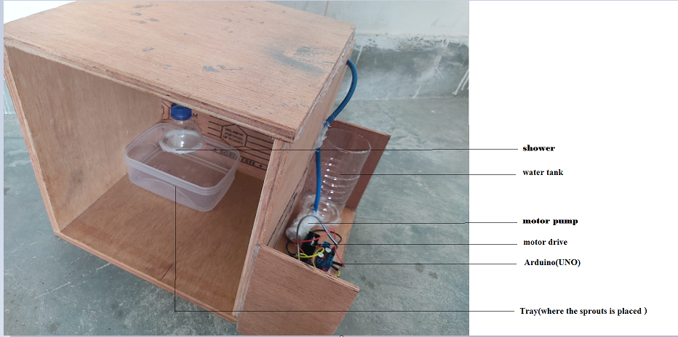

**Methodology:**

The sensor DHT 11 is used to monitor the temperature and humidity of the closed system .The temperature maintained in the system is around (70- 80 F) and the humidity level is around (30- 40 %) in a closed environment.

The chamber is constructed as covered steel chamber with thermocol bended layer with proper air circulation. The data which are collected from the system are send to cloud (Thinks speaks).

Sprouting of cereals is the process where it enrich the protein content in the cereals .

Basically sprouting needs some specific parameters such as temperature and humidity.

.

**Results and Discussion:**

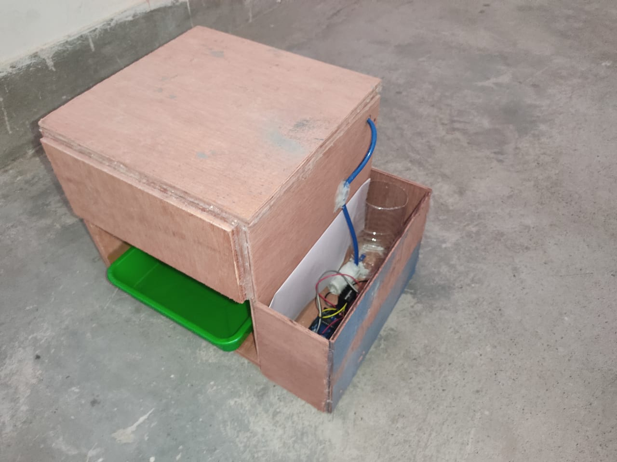

**Outcome/Scope:**

For the crop / food producing sector, Perrin noted, these basic resources include **land, water, and natural resources and critical factors such as climate and ecological resilience**. In agriculture, **cost of seed, manure's and fertilizers, irrigation** are the variable costs.

**Cost Analysis:**

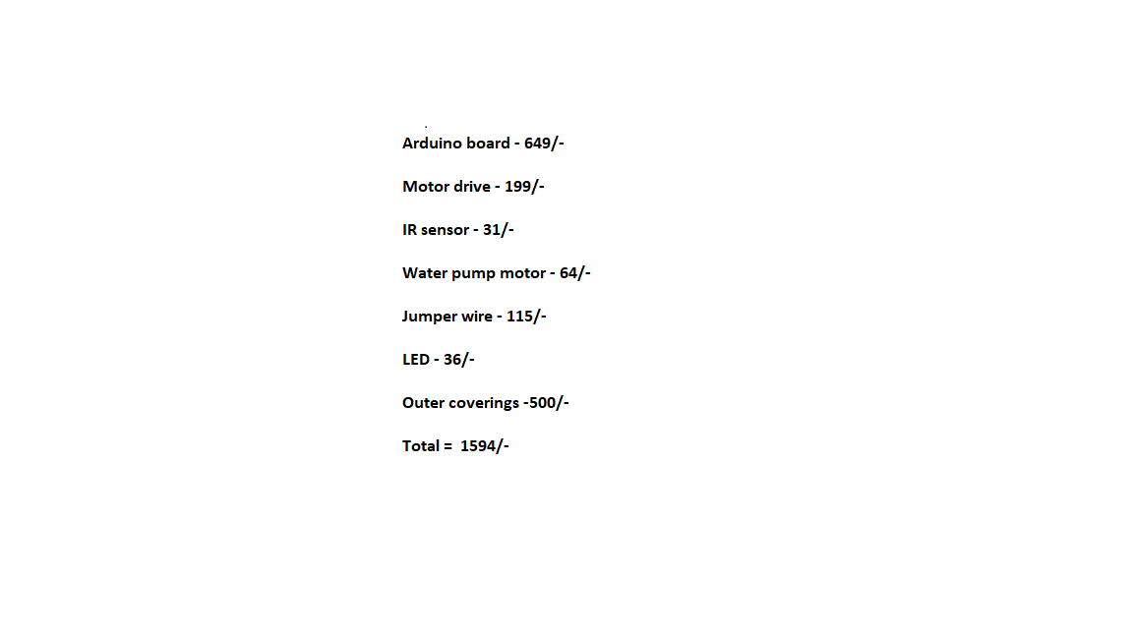

**References:**

<https://blog.arduino.cc/2022/09/13/build-your-own-automatic-bean-sprouter-for-superfood-meals/>